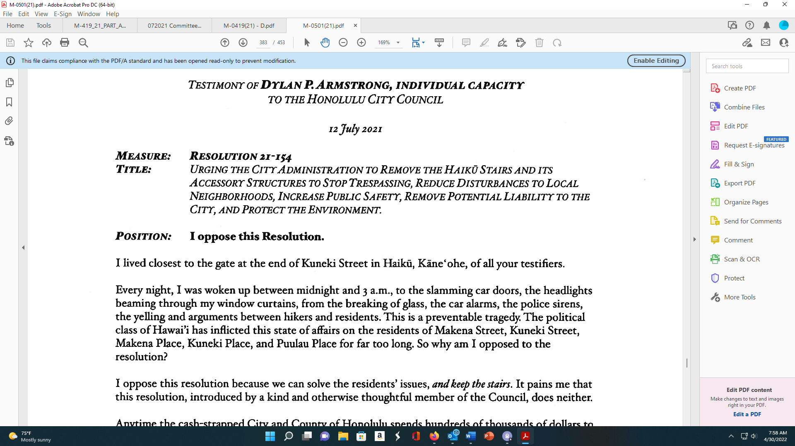
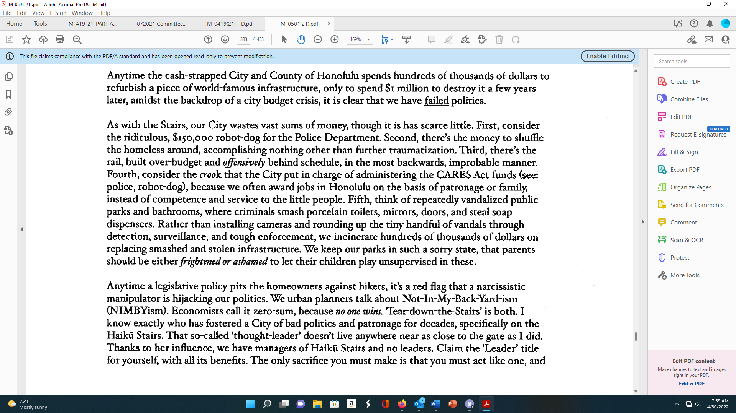
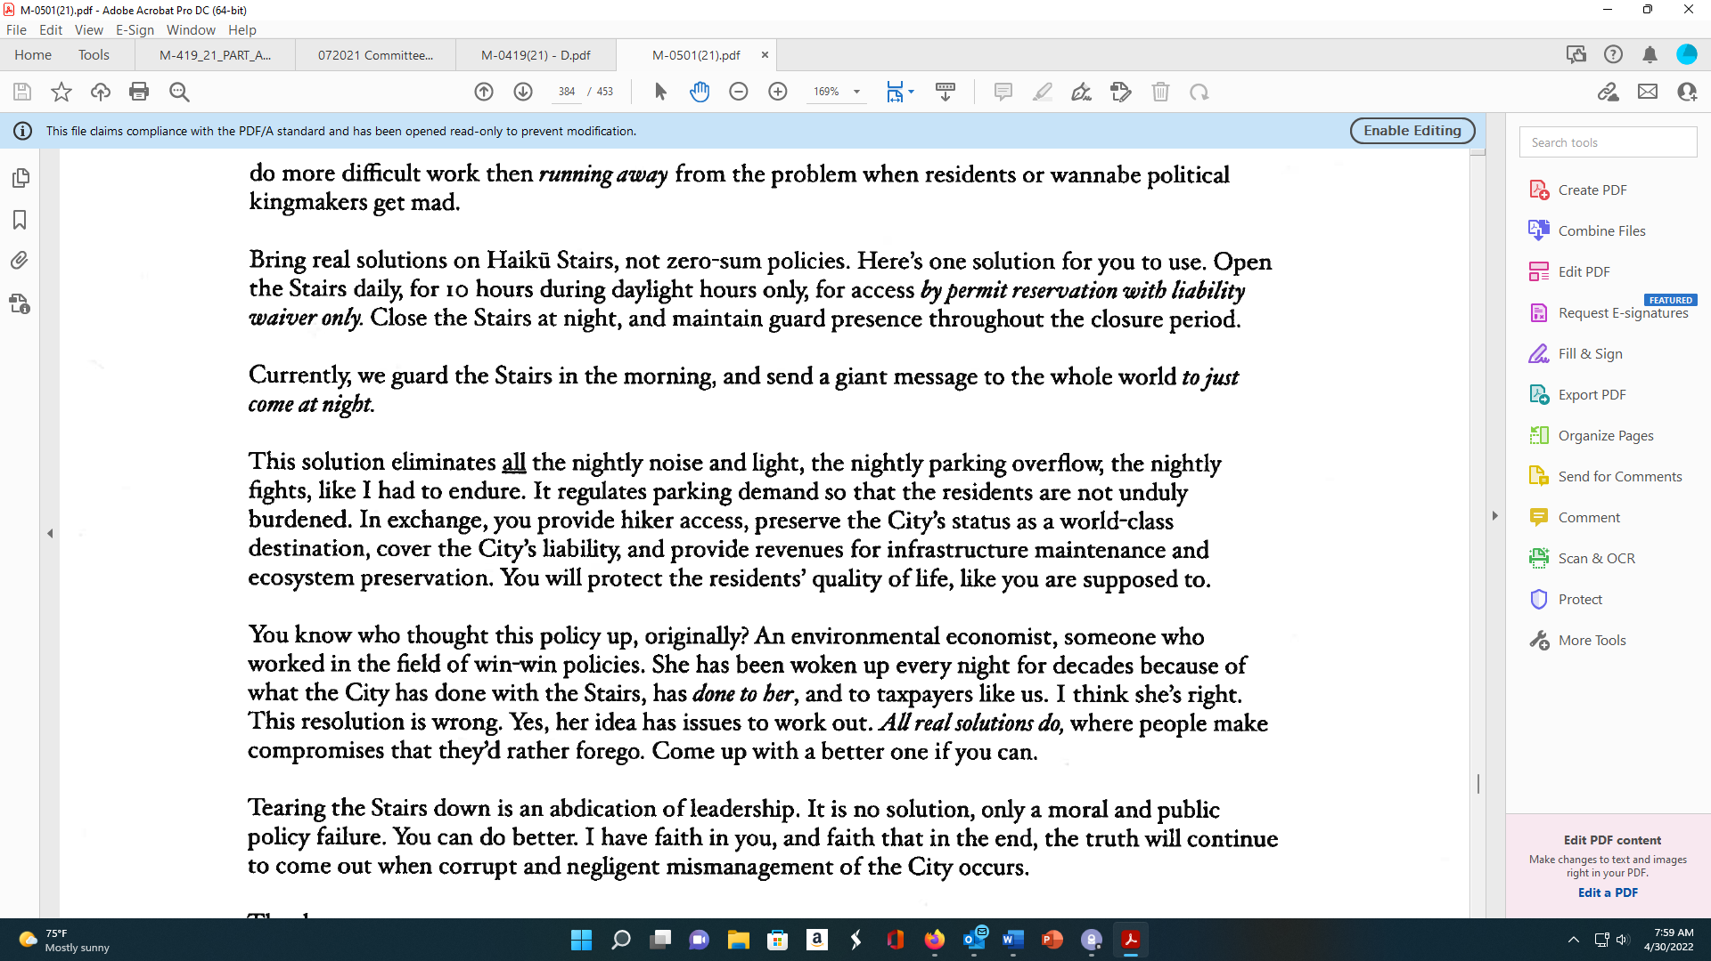

TESTIMONY OFDrLANP ARMSTRONG, INDIVIDUAL CAPACITY
TO THE HONOLULU CITY CouNcIL
12 July 2021
MEASURE: RESOLUTION 21-154
TITLE: URGING THE C’ITYADMINISTRATION TO REMOVE THE HAIKU STAIRS AND ITS
ACCESSORY STRUCTURES TO STOP TRESFASSING, REDUCE DISThRBANCES TO LOCAL
NEIGHBORHOODS, INCREASE PUBLIC SAFETY, REMOVE POTENTIAL LIABILITY TO THE
CITY, AND PROTECT THE ENVIRONMENT.
POSITION: I oppose this Resolution.
I lived closest to the gate at the end of Kuneki Street in Haiku, Kãne’ohe, of all your testifiers.
Every night, I was woken up between midnight and 3 a.m., to the slamming car doors, the headlights
beaming through my window curtains, from the breaking of glass, the car alarms, the police sirens,
the yelling and arguments between hikers and residents. This is a preventable tragedy. The political
class of Hawai’i has inflicted this state of affairs on the residents of Makena Street, Kuneki Street,
Makena Place, Kuneki Place, and Puulau Place for far too long. So why am I opposed to the
resolution?
I oppose this resolution because we can solve the residents’ issues, and keep the stairs. It pains me that
this resolution, introduced by a kind and otherwise thoughtful member of the Council, does neither.
Anytime the cash-strapped City and County of Honolulu spends hundreds of thousands of dollars to
refurbish a piece of world-famous infrastructure, only to spend $i miffion to destroy it a few years
later, amidst the backdrop of a city budget crisis, it is clear that we have failed politics.
As with the Stairs, our City wastes vast sums of money, though it is has scarce little. First, consider
the ridiculous, $150,000 robot-dog for the Police Department. Second, there’s the money to shuffle
the homeless around, accomplishing nothing other than further traumatization. Third, there’s the
rail, built over-budget and offensively behind schedule, in the most backwards, improbable manner.
Fourth, consider the crook that the City put in charge of administering the CARES Act funds (see:
police, robot-dog), because we often award jobs in Honolulu on the basis of patronage or family,
instead of competence and service to the little people. Fifth, think of repeatedly vandalized public
parks and bathrooms, where criminals smash porcelain toilets, mirrors, doors, and steal soap
dispensers. Rather than installing cameras and rounding up the tiny handful of vandals through
detection, surveillance, and tough enforcement, we incinerate hundreds of thousands of dollars on
replacing smashed and stolen infrastructure. We keep our parks in such a sorry state, that parents
should be eitherfrightened or ashamed to let their children play unsupervised in these.
Anytime a legislative policy pits the homeowners against hikers, it’s a red flag that a narcissistic
manipulator is hijacking our politics. We urban planners talk about Not—In-My-Back-Yard-ism
(NIMBYism). Economists call it zero-sum, because no one wins. Tear-down-the-Stairs’ is both. I
know exactly who has fostered a City of bad politics and patronage for decades, specifically on the
Haikã Stairs. That so-called ‘thought-leader’ doesn’t live anywhere near as close to the gate as I did.
Thanks to her influence, we have managers of Haiku Stairs and no leaders. Claim the ‘Leader’ title
for yourself, with all its benefits. The only sacrifice you must make is that you must act like one, and
do more difficult work then running away from the problem when residents or wannabe political
kingmakers get mad.
Bring real solutions on Haiku Stairs, not zero-sum policies. Here’s one solution for you to use. Open
the Stairs daily, for jo hours during daylight hours only, for access by permit reservation with liability
waiver only. Close the Stairs at night, and maintain guard presence throughout the closure period.
Currently, we guard the Stairs in the morning, and send a giant message to the whole world tojust
come at night.
This solution eliminates Ji the nightly noise and light, the nightly parking overflow, the nightly
fights, like I had to endure. It regulates parking demand so that the residents are not unduly
burdened. In exchange, you provide hiker access, preserve the City’s status as a world-class
destination, cover the City’s liabilit)ç and provide revenues for infrastructure maintenance and
ecosystem preservation. You will protect the residents’ quality of life, like you are supposed to.
You know who thought this policy up, originally? An environmental economist, someone who
worked in the field of win-win policies. She has been woken up every night for decades because of
what the City has done with the Stairs, has done to her, and to taxpayers like us. I think she’s right.
This resolution is wrong. Yes, her idea has issues to work out. Allreal solutions do, where people make
compromises that they’d rather forego. Come up with a better one if you can.
Tearing the Stairs down is an abdication of leadership. It is no solution, only a moral and public
policy failure. You can do better. I have faith in you, and faith that in the end, the truth will continue
to come out when corrupt and negligent mismanagement of the City occurs.
Thank you,
Dylan P Armstrong, individual capacity
dyIan.p.armstrongcçimaiI.com

